Ta’Quawn Watts

Project 2 Java Program Written Documentation

Project 2’s Java program has three classes and three tester classes. The three classes are CSVWriter, JFreeChartsGrapher, and StatsLibrary. The three tester classes are TestCSVWriter, TestJFreeChartsGrapher, and TestStatsLibrary.

StatsLibrary is a class hosting a library of various functions used primarily in statistics. The methods included are findMean(), findMedian(), findMode(), findStdDev(), findUnion(), findIntersection(), findComplement(), factorial(), solveCombo(), and solveBinoDistrib(), solveGeoDistrib().

findMean() returns the mean of a list. findMedian returns the median of a list. findMode() returns the mode of a list and returns null if there are no mode or multiple. findStdDev() returns the standard deviation using the formula $s= \sqrt{s^{2}}$. TestStatsLibrary uses the mentioned methods generate the following output for an ArrayList named “someNumbers” that includes the numbers: [1.0, 2.0, 3.0, 4.0, 5.0].

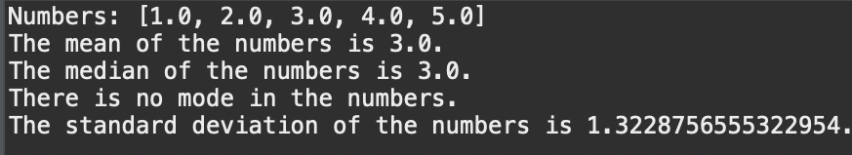

In this ArrayList, findMode() returns “There is no mode in the numbers”. If the ArrayList someNumbers is modified to contain a mode, TestStatsLibrary will generate the following output:

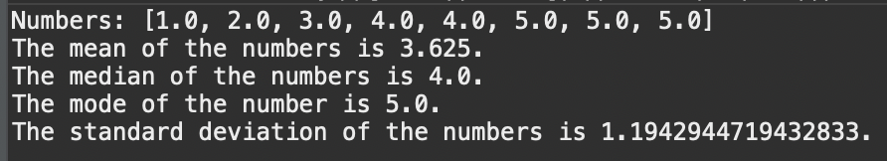

findUnion() returns the union of subset A and subset B, findIntersection() returns the intersection of subset A and subset B, and findComplement returns the complement of a subset. TestStatsLibrary uses the mentioned methods to generate the following output for the listed ArrayLists: set containing [1, 2, 3, 4, 5, 6, 7, 8, 9], listA containing [2, 4, 6], listB containing [1, 2, 5, 7, 9]

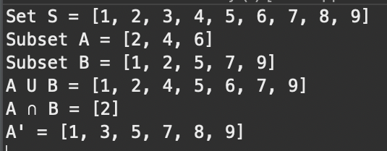

factorial() returns the factorial of an integer. solveCombo returns the combination of two integers using the formula $\left({n \atop r}\right)= C_{r}^{n}= \frac{P_{r}^{n}}{r!}=\frac{n!}{r!\left(n-r\right)!}$. solveBinoDistrib returns the binomial distribution probability using the formula $p\left(y\right)=\left({n \atop r}\right)p^{y}q^{n-y}$. solveGeoDistrib returns the geometric distribution using the following formulas:

$$μ=E\left(Y\right)=\frac{1}{p} \\ σ^{2}=V\left(Y\right)= \frac{1-p}{p^{2}}$$

TestStatsLibrary uses the mentioned methods to generate the following output:

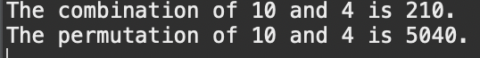





solveHyperGeo() returns the hypergeometric distribution probability of four integers using the formula $p\left(y\right)= \frac{\left({r \atop y}\right)\left({N-r \atop n-y}\right)}{\left({N \atop n}\right)}$. solvePossDistrib returns the Poisson distribution probability of two integers using the formula $p\left(y\right)= \frac{λ^{y}}{y!}e^{-λ}$. solveTchebTheor returns a percentage probability using the Tchebysheff’s theorem $P\left(\left|Y-μ\right|<kσ\right)≥1-\frac{1}{k^{2}}$.

TestStatsLibrary uses the mentioned methods to generate the following output:

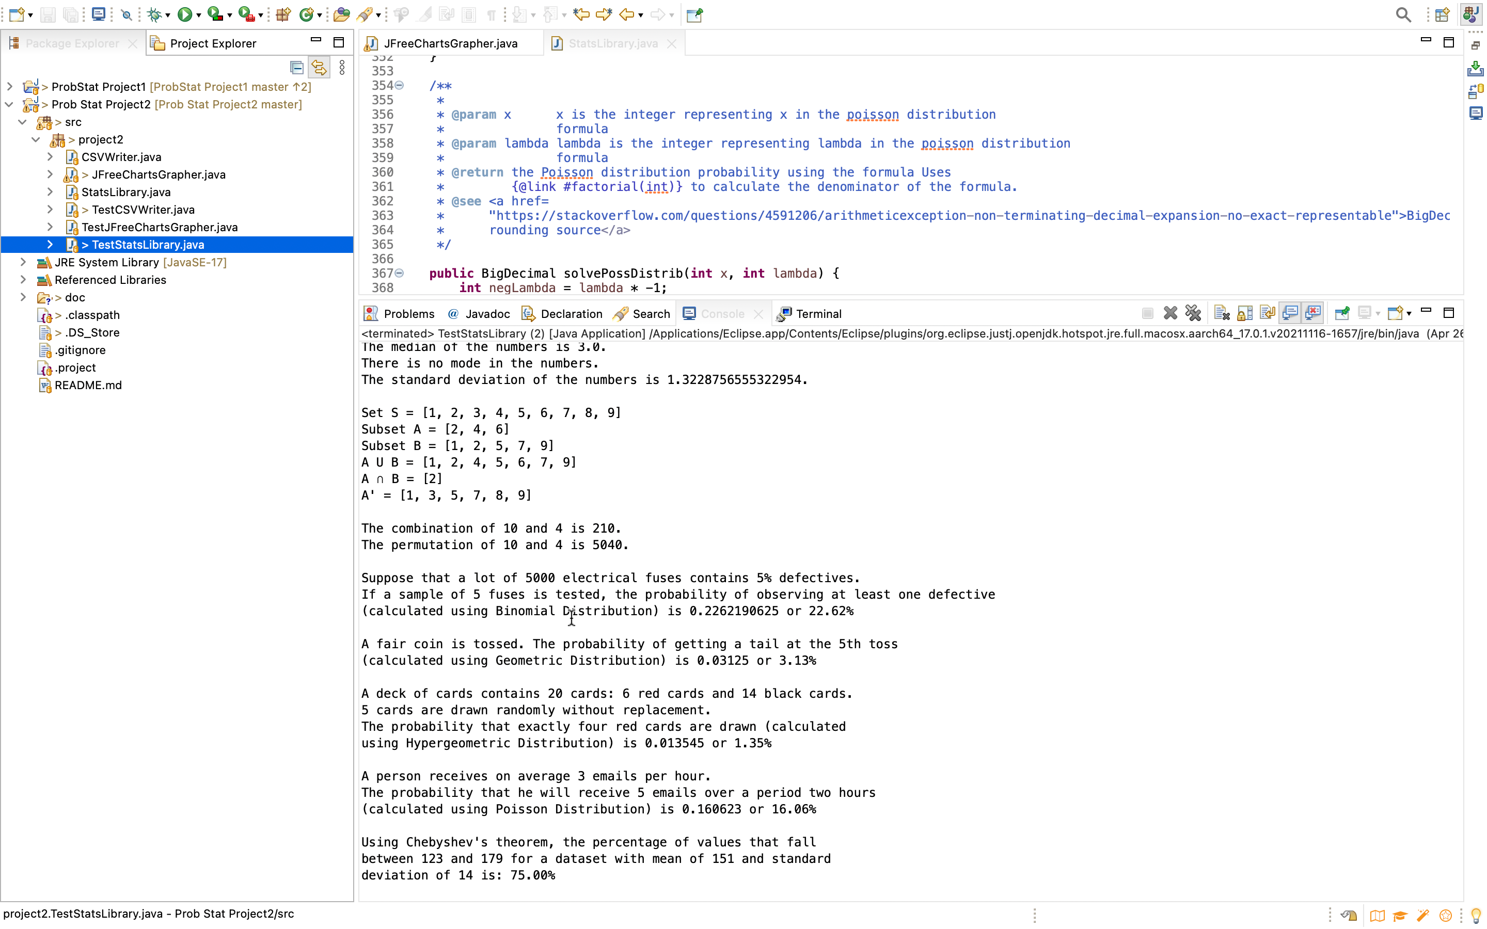

CSVWriter is a class that creates a CSV and writes the input x and output y values of a function into it. CSVWriter “salts” data from a CSV file containing x and y values, adding, or subtracting number randomized from a range. CSVWriter also smooths CSV files containing x and y values using a window size value. CSVWriter contains five methods: functionSolver(), writeToCSV(), saltCSV(), smoothData(), smoothCSV().

functionSolver() returns the integer output of the function $x^{2}+2x+1$. writeToCSV() creates a CSV file named data.csv and writes the x and y values according to the specified range. writeToCSV will then print the location of the CSV. For example, if the range was -5, 5, data.csv will contain these x and y values and writeToCSV() will print the CSV path:

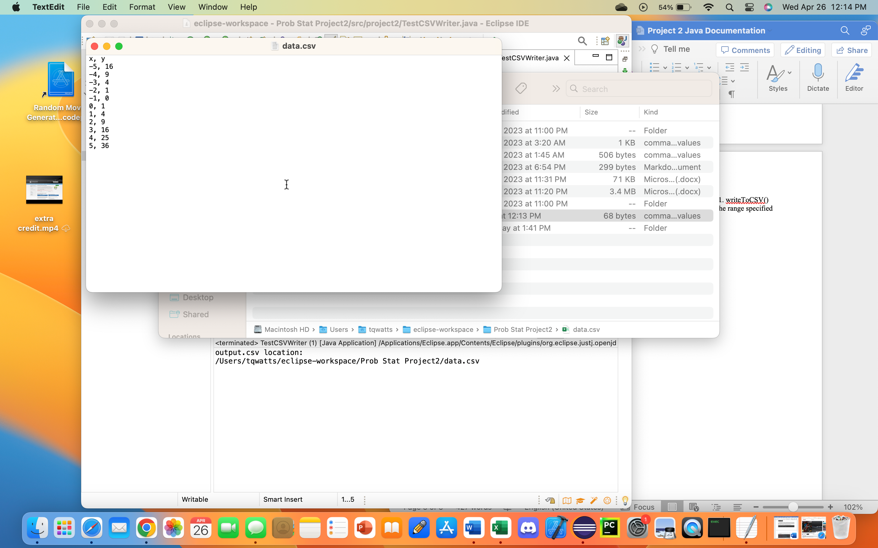

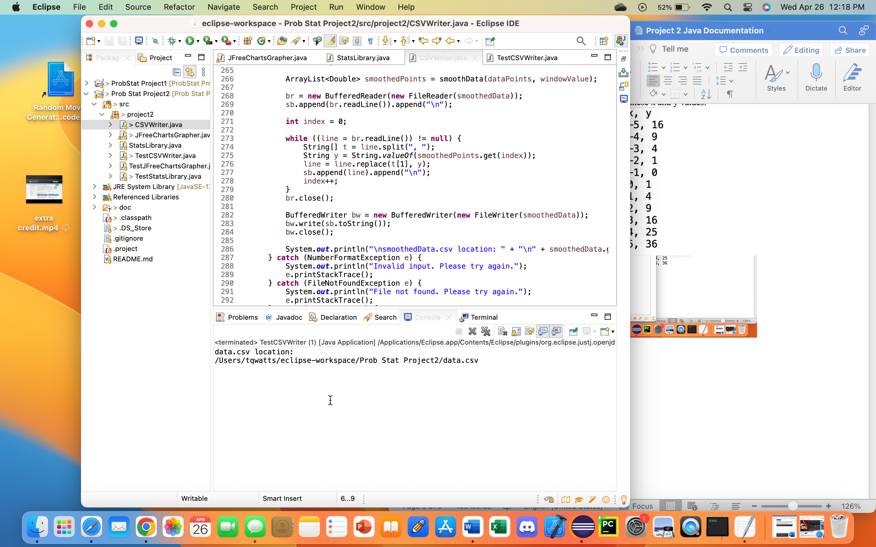

saltCSV() copies the CSV inputted and creates a new CSV file with salted values named saltedData.csv. saltCSV() will add or subtract randomly generated numbers within a specified range. Afterwards, it will print the location of saltedData.csv. For example, if the range was 5, 15, saltedData.csv may contain these x and salted y values and saltCSV() will print the CSV path:

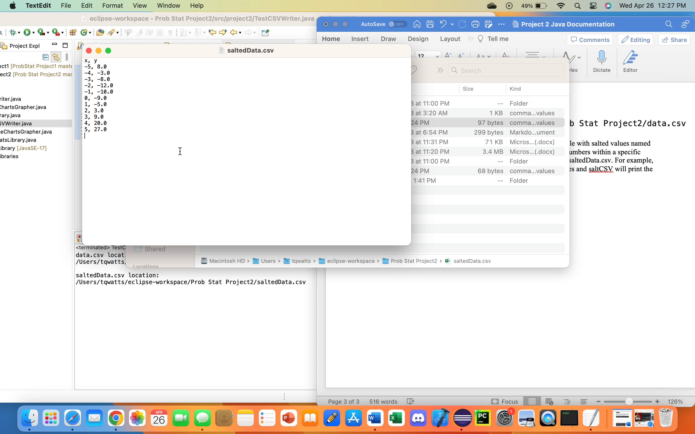

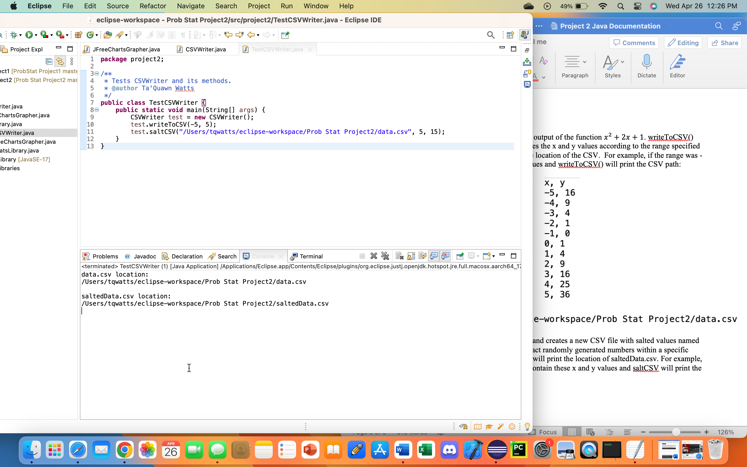

smoothData() takes the data from a list and averages it will a specific range of points around it, known as “smoothing”. It returns a new list of data that have been smoothed. Using smoothData(), smoothCSV() copies the inputted CSV file and smooths the y values, creating a file named smoothedData.csv. Afterwards, smoothCSV() will print the location of smoothedData.csv. For example, if the range (window size) was 3, smoothData.csv may contain these x and smoothed y values and smoothCSV() will print the CSV path:

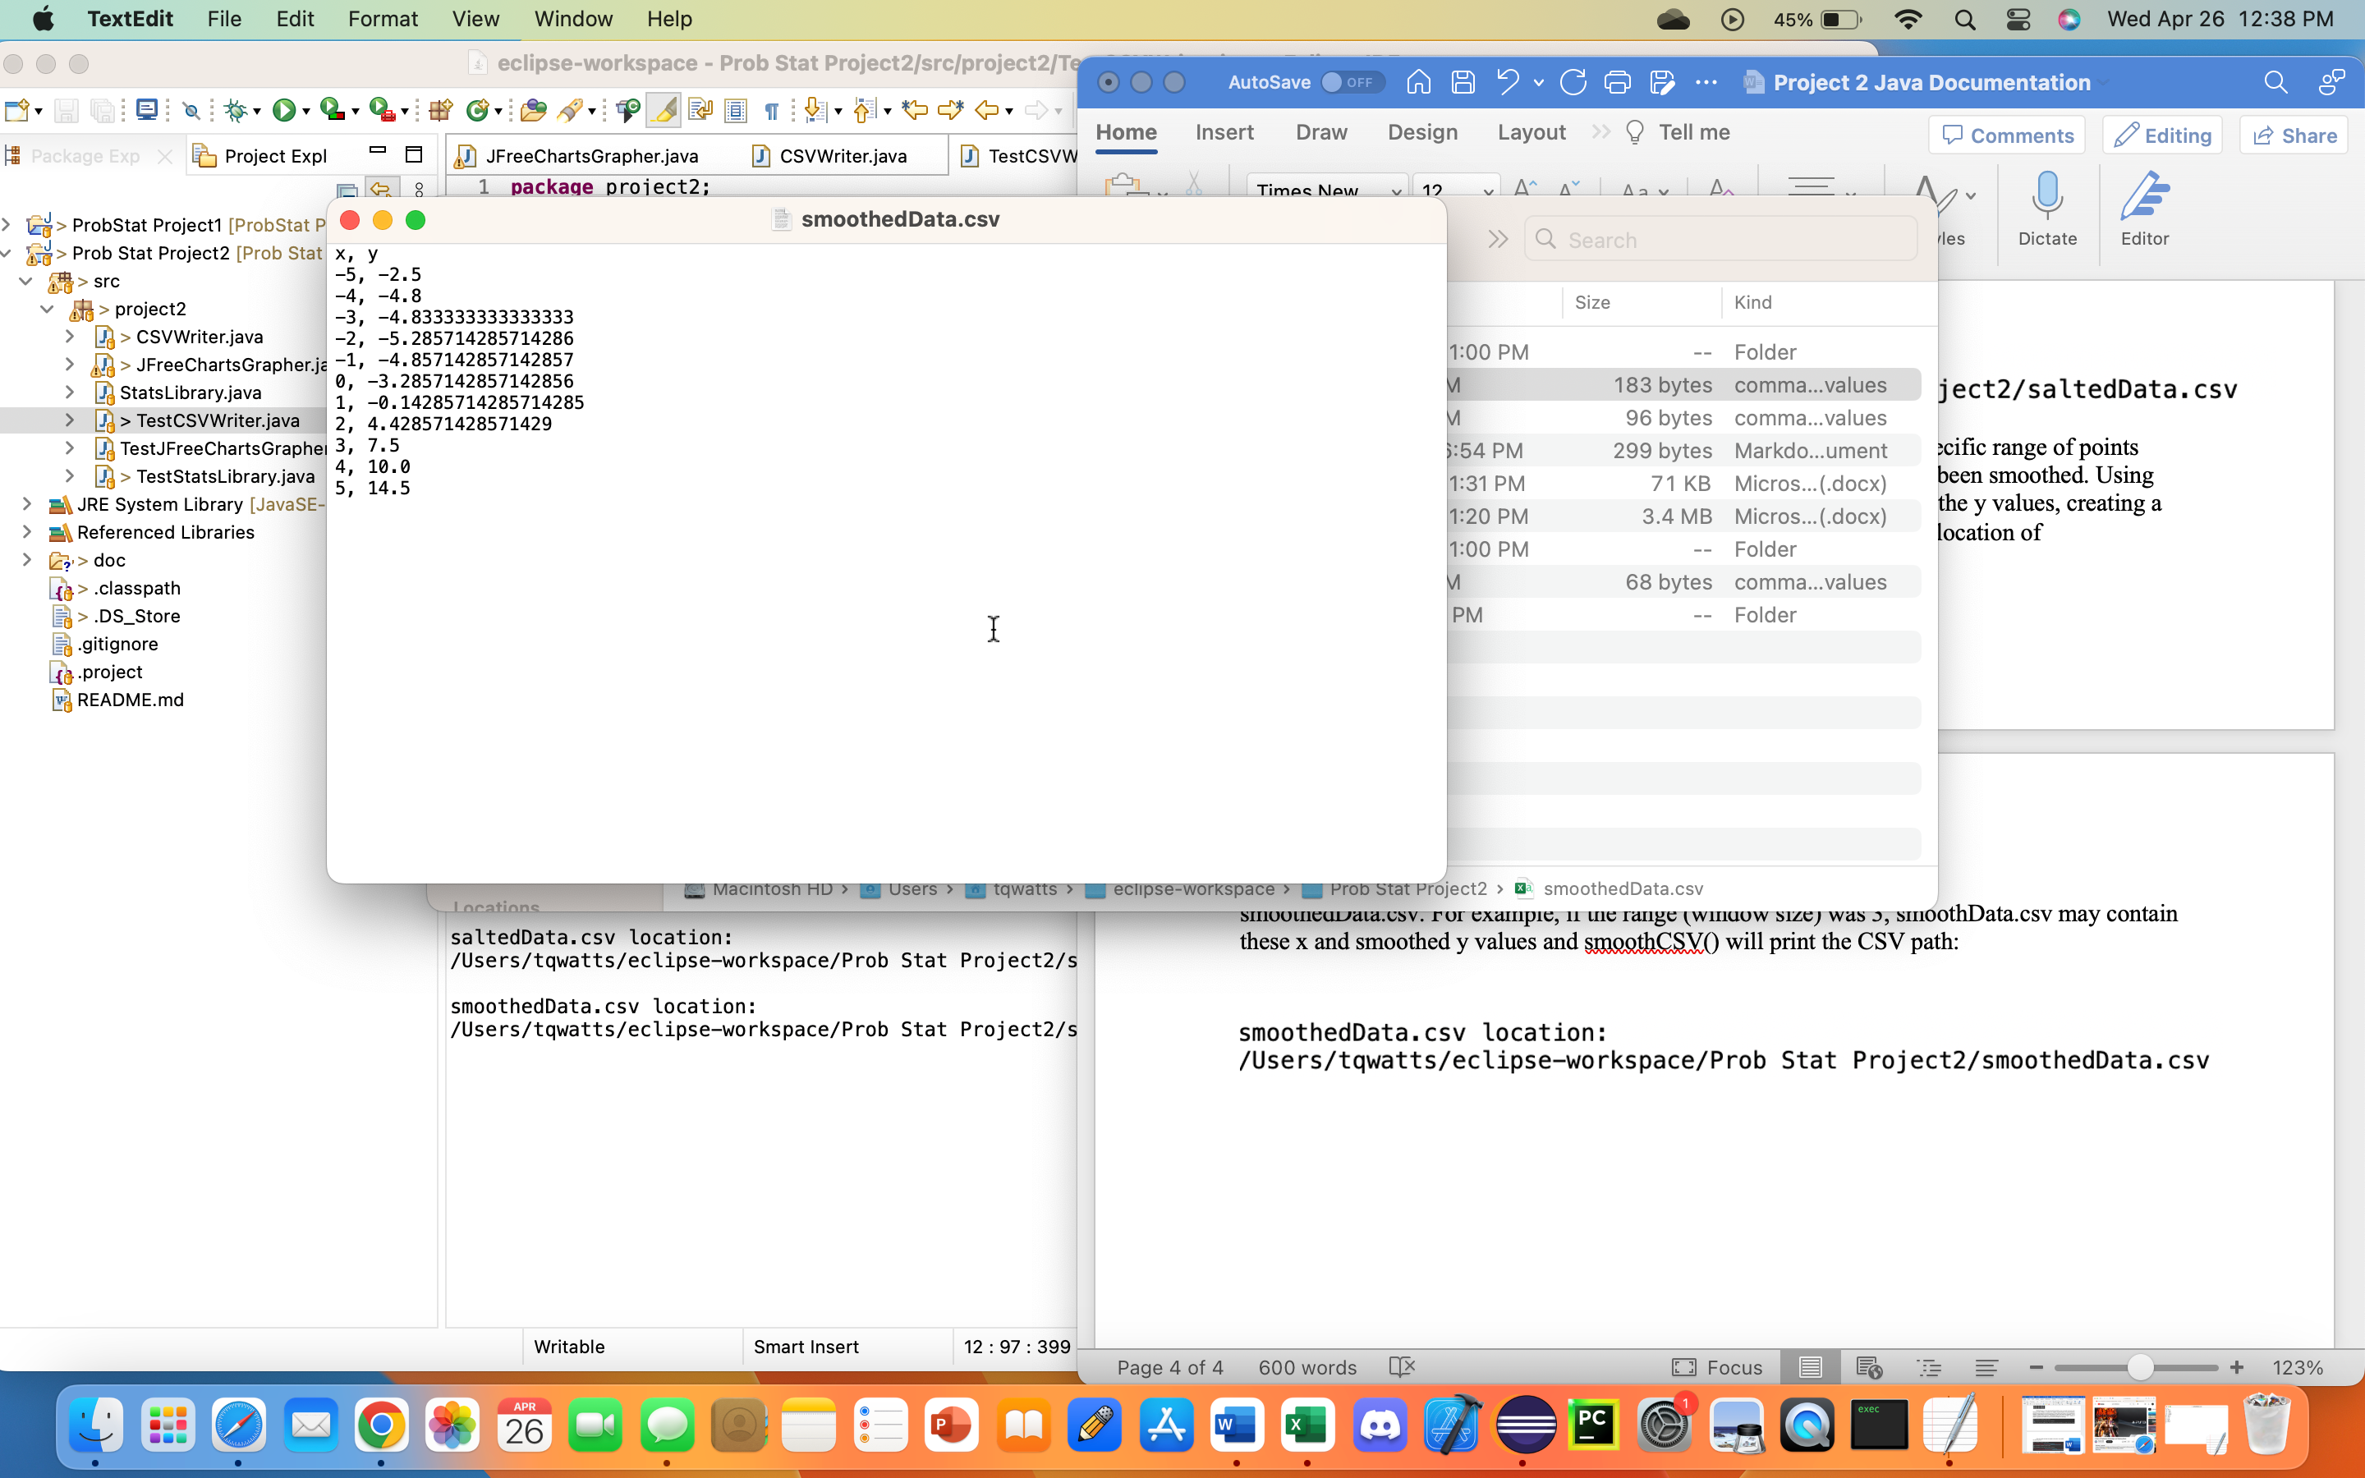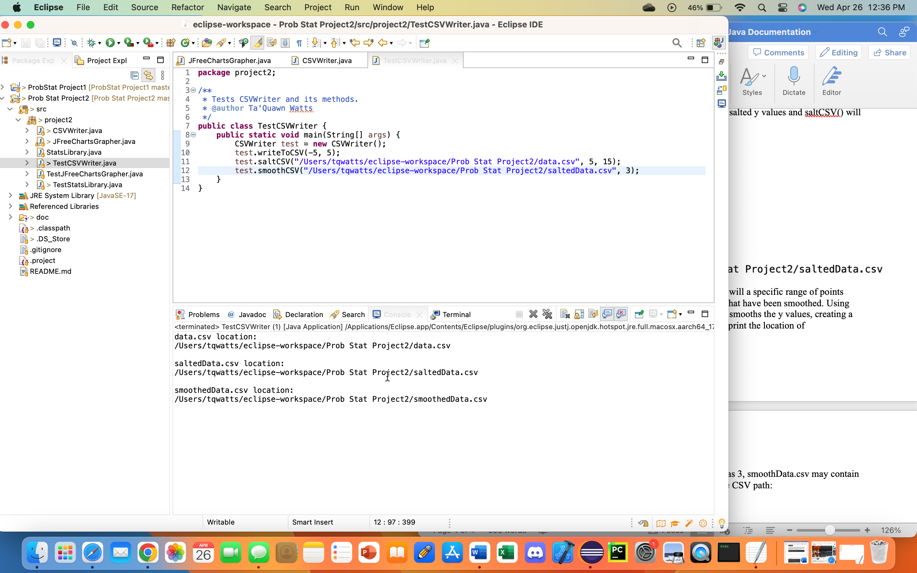

JFreeChartsGrapher is a class that implements Apache Commons Math Library version 3.61 and JFreeCharts version 1.0.19 to plot, graph, salt, and smooth a function. JFreeChartsGrapher has five methods: functionSolver(), functionXY(), saltXY(), smoothXY(), and displayGraphs().

functionSolver() returns the integer output of the function $x^{2}+2x+1$. functionXY() uses functionSolver() and JFreeCharts to create a dataset of a x and y points within a specified range. It then returns the dataset.

saltXY() takes the y values from the inputted dataset and adds or subtract randomly generated numbers from a specified range using Apache Commons Math Library. It uses JFreeCharts to creates a new dataset with the x and salted y points and returns it.

smoothXY() takes the y values from the inputted dataset and uses Apache Commons Math Library to smooth the values according to the window size. It uses JFreeCharts to add the x and smoothed points to a dataset and returns it.

displayGraphs() uses functionXY(), saltXY(), and smoothXY() to generate three datasets. Using JFreeCharts, displayGraphs() plots and graphs each data set and displays the graphs with a title respective to the dataset. When running TestJFreeCharts and calling displayGraphs() with the parameters -25, 25, 0, 100, 5, it may display the following graphs:

